***DAY 8 ASSIGNMENT***

* ***Assignment 0:***

***A simple shell script***

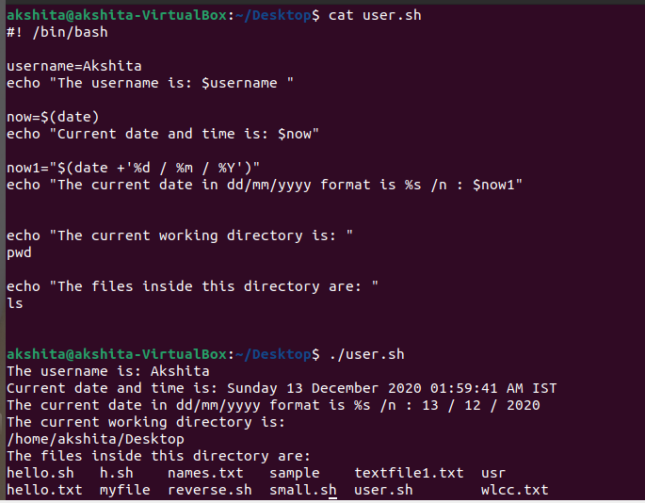

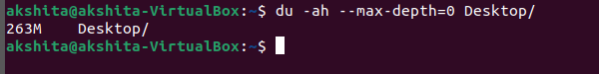

* ***Assignment 1:***

***A shell script for renaming the file with the date extension***

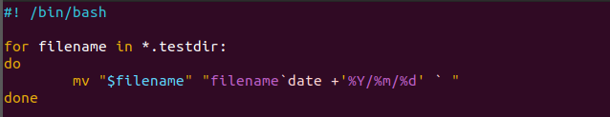

* ***Assignment 2:***

***A shell script for reversing a number***

